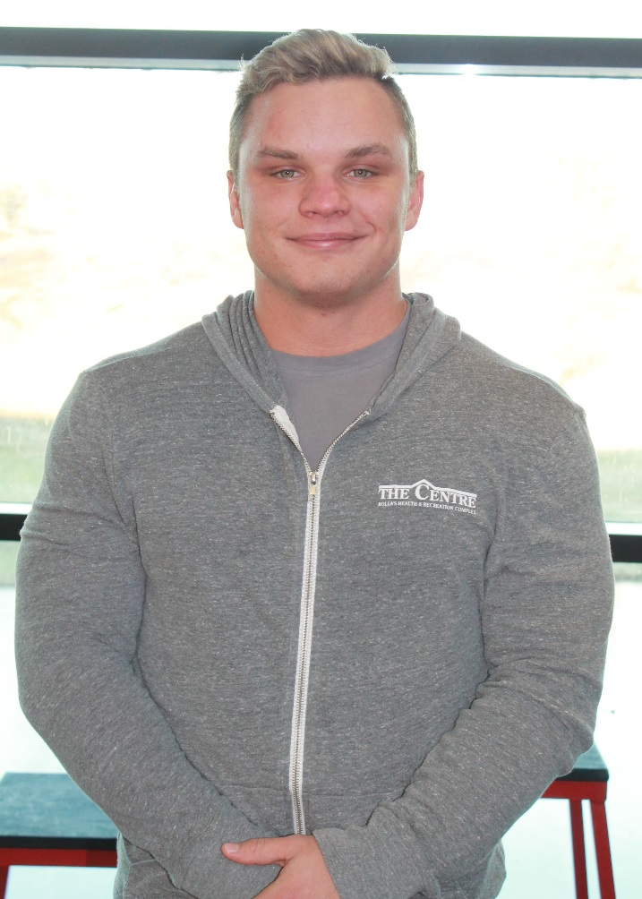
Trevor Mock, CPT
American Council on Exercise –ACE

Hello, my name is Trevor! I am the newest personal trainer here at The Centre. I have had a love and a passion for fitness and helping people reach their fitness goals, for as long as I can remember. I have plans to compete in NPC Men’s Classic Physique Bodybuilding competition very soon and currently play Rugby for the Miner’s Club Team. I am a senior at MS& T studying Petroleum Engineering. I would love to help you in achieving your fitness needs!
I enjoy working with and offer training to all age ranges of clients, all levels of fitness, and athleticism. With tailored workout plans for each client’s goals, I will have you on your way to a more fit you! If you see me around, please say hello!

